**Batch: C3 Roll No.:16010123217**

**Experiment / assignment / tutorial No. 3**

**Grade: AA / AB / BB / BC / CC / CD /DD**

**Signature of the Staff In-charge with date**

|  |
| --- |
| **Title: :** Implementation of Database in SQL -DDL |

**Objective:** Define/modify database definitions with proper constraints

_____________________________________________________________

**Expected Outcome of Experiment:**

CO 2: Convert entity-relationship diagrams into relational tables, populate a relational

database and formulate SQL queries on the data Use SQL for creation and query the database.

CO 3: Define and apply integrity constraints and improve database design using normalization techniques.

_______________________________________________________________________

**Pre Lab/ Prior Concepts**:

Resources used: Postgresql

**Theory:** The set of relations in a database must be specifies to the system by means of a data definition language (DDL). The SQL DDL allows specification of not only a set of relations but also specific information about the relation including,

1. The schema for each relation
2. The domain of values associated with each attribute
3. The integrity constraints
4. The set of indices to be maintained for each relation
5. The security and authorization information for each relation
6. The physical storage structure of each relation on disk

**Syntax Create Table:**

create table employee(ssn,fname varchar(10), mname varchar(10), lname varchar(10), desg varchar(20), gender varchar(5), addr varchar(20), bdate datetime, sal float,primary key(ssn));

create table manages(ssn int, dept_code int, start_dt datetime, foreign key(ssn) references employee, foreign key(dept_code) references department, key(ssn,dept_code) ) on delete set null

**Data Constraints**

Business managers of the organization determine a set of rules that must be applied before the data is stored in the database. The application of such rules on raw data ensures **data integrity**.

**Eg:-** An employee belonging to the Sales department cannot have a salary higher than Rs. 1000.

An employee has an unique identification number.

**Applying Data Constraints**

Oracle permits data constraints to be attached to table columns using SQL syntax. Constraints can be attached to table columns using Alter table.

**Unique Constraint**

**Unique Constraint- At column level Syntax**

**<ColumnName><Datatype>(<size>) UNIQUE**

**Unique Constraint- At table level**

**CREATE TABLE<TableName>(**

**<ColumnName><Datatype>(<size>)**

**<ColumnName><Datatype>(<size>)**

**<Columnname><Datatype>(<size>) UNIQUE(<ColumnName1>,<ColumnName2>);**

**Implementation Details (Problem Statement, Query and Screenshots of Results):**

**Problem Statement**

CodeKeep is a platform designed to help competitive programmers manage and track their competitive programming profiles and upcoming contests. The platform enables users to store their achievements across multiple competitive programming sites, view upcoming contests in a unified calendar, and monitor their progress in various competitions. The system will store information related to users, contests, platforms, and user participation in contests. Additionally, users will be able to link multiple profiles from different platforms to their account.

**Query Used:**

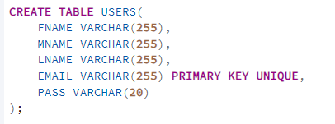

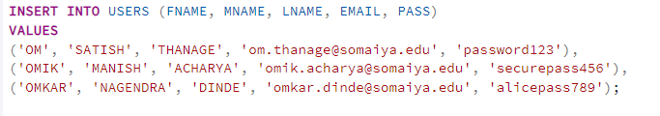

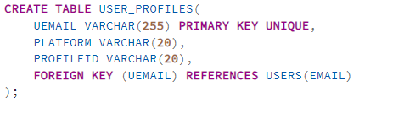

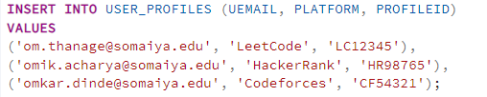

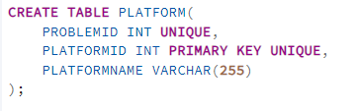

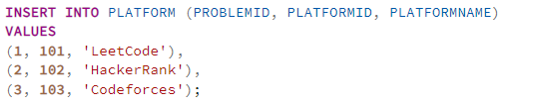

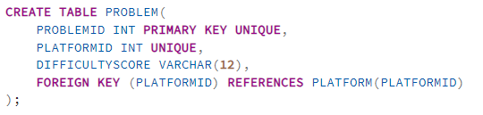

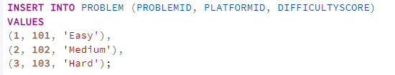

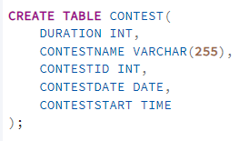

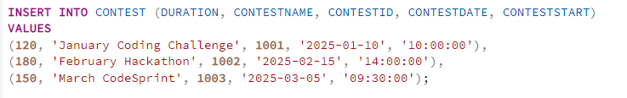

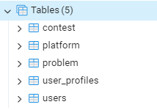

**Output:**

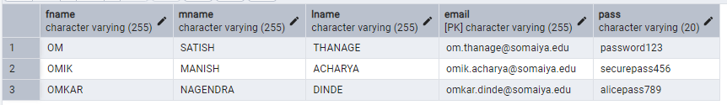

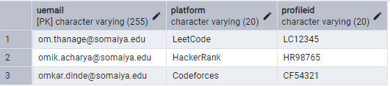

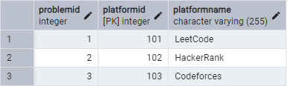

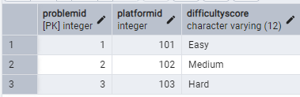

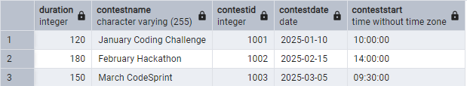

**Some of the commands used on Dummy DataBase (PostLab Question 3):**

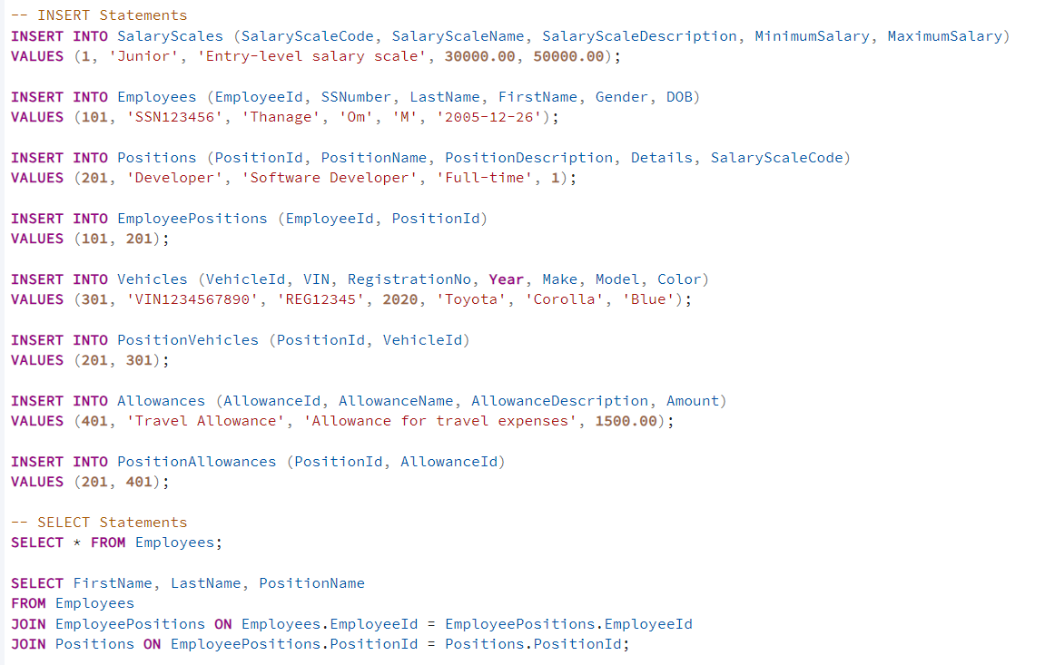

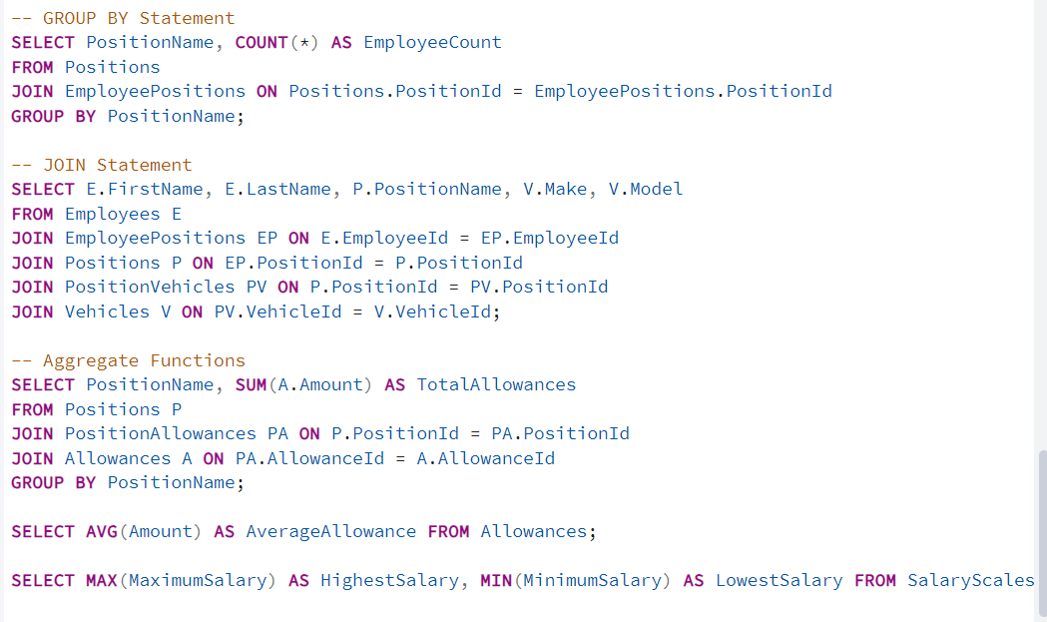

GROUP BY:

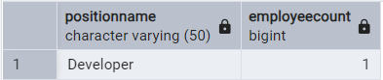

JOIN:  


Aggregate Functions:

SUM:  
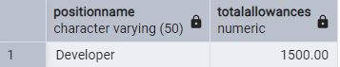

Average :  
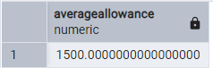

MIN and MAX:  
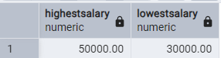

**Post Lab Questions:**

1. **Explain in brief the following terms:**
   1. **Database:  
      A database is an organized collection of data that allows easy access, management, and updating. It stores information electronically and supports operations like querying, inserting, updating, and deleting data.**
   2. **Types of Databases:**

**Relational Databases (RDBMS): Store data in tables with rows and columns (e.g., MySQL, PostgreSQL).**

**NoSQL Databases: Handle unstructured data using key-value pairs, documents, graphs, or wide-columns (e.g., MongoDB, Cassandra).**

**Hierarchical Databases: Organize data in a tree-like structure (e.g., IBM IMS).**

**Network Databases: Use graph structures with nodes and edges to represent relationships.**

**Object-oriented Databases: Store data as objects, similar to object-oriented programming (e.g., db4o).**

* 1. **SQL Data Types:  
     SQL data types define the kind of data that can be stored in a table's column. Common types include:**

**Numeric: INT, FLOAT, DECIMAL**

**String/Text: CHAR, VARCHAR, TEXT**

**Date/Time: DATE, TIME, DATETIME, TIMESTAMP**

**Boolean: BOOLEAN or BOOL (stores TRUE/FALSE values)**

* 1. **Foreign Key:  
     A foreign key is a column (or set of columns) in one table that creates a relationship with the primary key of another table. It ensures referential integrity by enforcing that the value in the foreign key column matches an existing value in the referenced table.**

1. **What are the commands to:**
2. **Delete an entire table.**
3. **To view a database.**
4. **To select & view all the columns.**

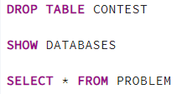

1. **For the given ER model and relational model , using DDL commands write syntax to create CREATE Tables with all possible integrity constraints.**

# Problem Statement: A small accounting firm wants a simple HR application that will help it to keep track of its employees, their positions, allowances, salary scales, and which company vehicles their employees drive. The application must keep track of all the positions at the firm, the employees filling these positions, the allowances for these positions, the salary scales for these positions, and the company vehicles assigned to these positions.

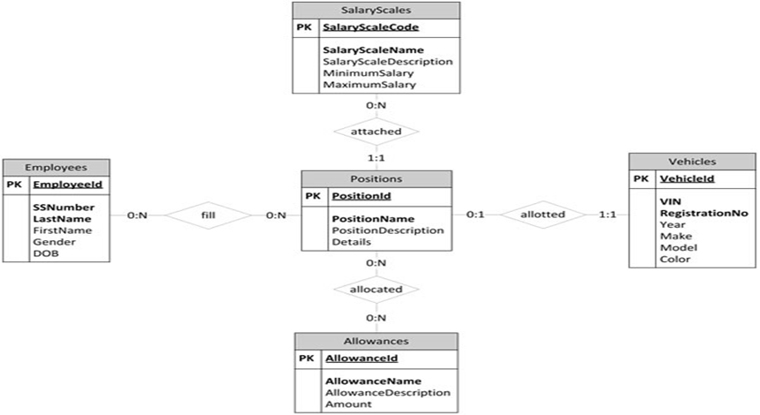

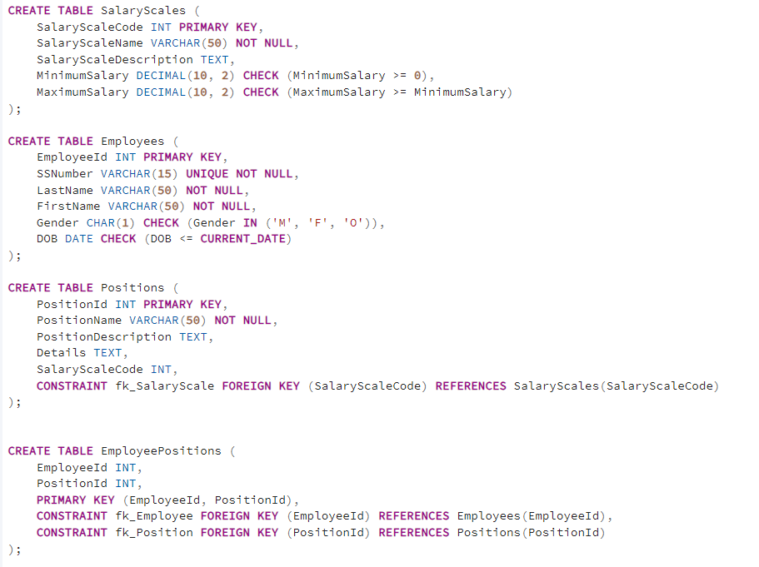

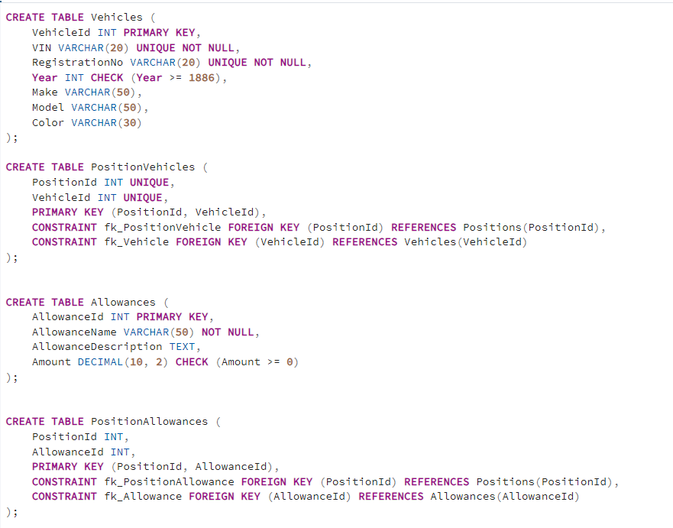

**Conclusion:** From this experiment we learnt to create database and its structure using pgadmin4